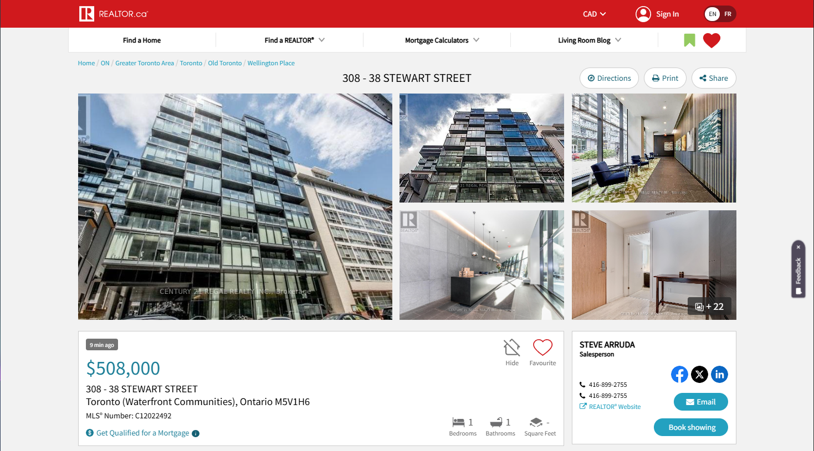

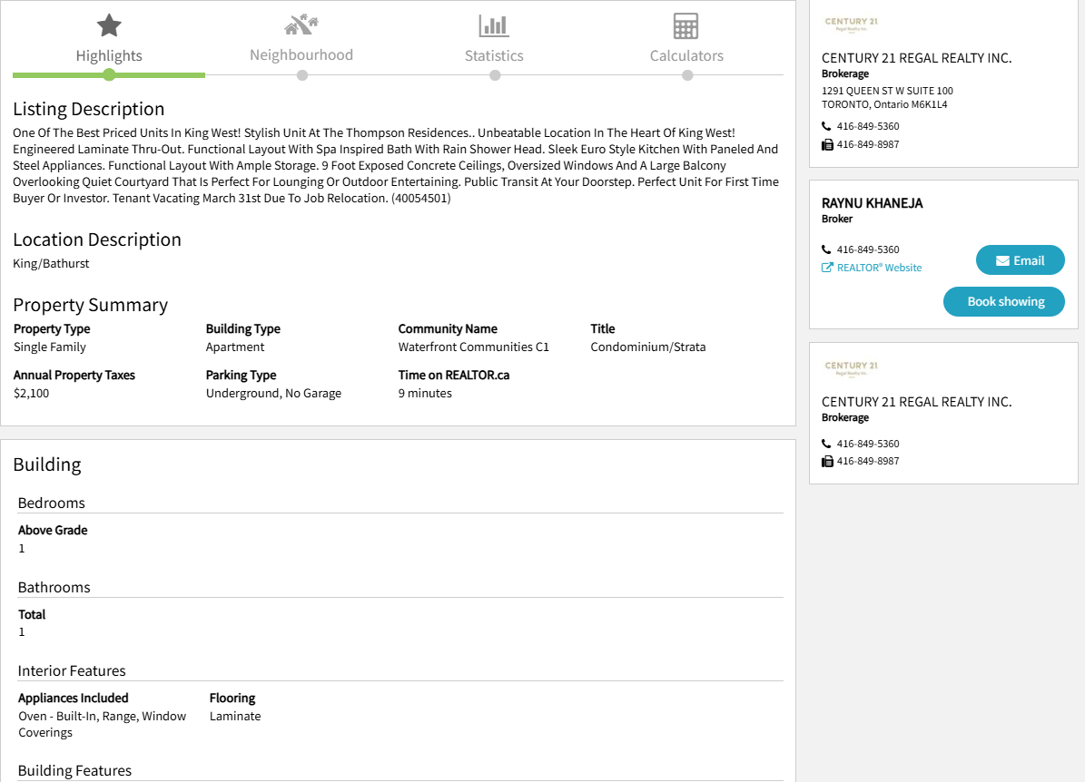

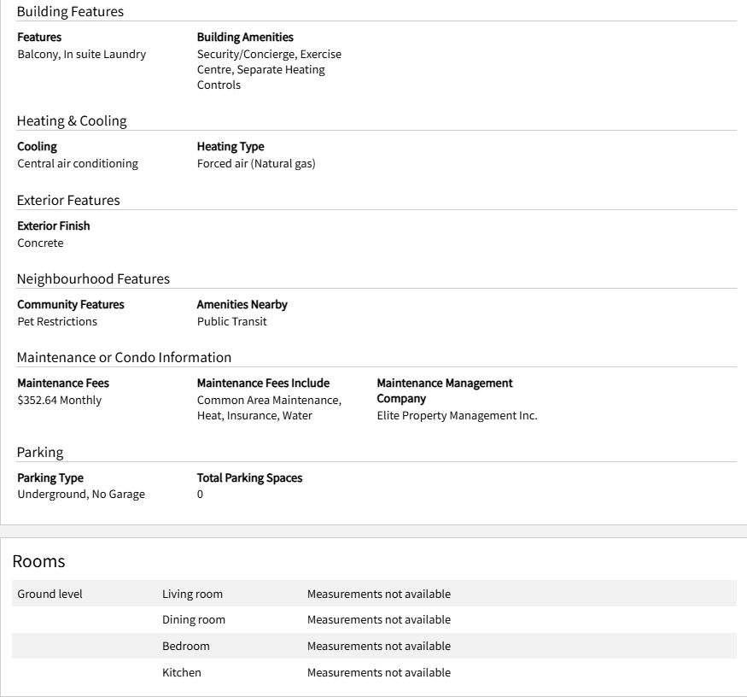

|  |  |  |  |  |  |  |  |
| --- | --- | --- | --- | --- | --- | --- | --- |
| Are you a first-time homebuyer (yes/no)? | | Yes | | Down Payment A: | Down Payment B: | | Down Payment C: |
| Cost of the Home | | $508,000 | | % | | % | % |
| Down Payment Amount  Your equity (financial contribution to the purchase of the home) | | | | $ | | $ | $ |
| Initial Mortgage Required (cost of home – down payment) | | | | $ | | $ | $ |
| Mortgage Loan Insurance Cost (is applicable) | | | | $ | | $ | $ |
| Final Mortgage Amount Required  (initial mortgage + mortgage insurance if applicable) | | | | $ | | $ | $ |
| Closing Costs | Provincial Land Transfer Taxes/Fees (if applicable) | | $ | *[Provincial Taxes + Municipal Taxes] – All Rebates = Total Taxes/Fees Payable*  *(enter total in this box – cannot be a refund)*  $ | | | |
| Municipal Land Transfer Taxes/Fees (if applicable) | | $ |
| Land Transfer Rebates - provincial & municipal (if applicable) | | - $ |
| Cost of Home Inspection | | | $ | | | |
| Cost of Appraisal by the Lender | | | $ | | | |
| Legal Fees | | | $ | | | |
| Renovation/Improvement and Moving Expenses (optional discretionary amount) | | | $ | | | |
| Emergency Fund (optional discretionary amount) | | | $ | | | |
| Total Budget Required at Time of Purchase:  down payment + all closing costs, explored for each of the three down payment options | | | | $ | | $ | $ |

|  |  |  |  |  |  |  |
| --- | --- | --- | --- | --- | --- | --- |
|  | Name of Financial Institution | Mortgage Term | Fixed  OR  Variable | Open  OR  Closed | Interest Rate | Link / Screenshot |
| Mortgage A |  | 5y | F | C |  |  |
| Mortgage B |  | 5y | V | C |  |  |
| Mortgage C |  | 3y | F | C |  |  |
| Mortgage D |  | 3y | V | C |  |  |
| Mortgage E |  | 1y |  |  |  |  |
| Mortgage F |  |  |  | O |  |  |
| Mortgage G |  |  |  |  |  |  |
| Mortgage H |  |  |  |  |  |  |

***\* If you are unable to find a mortgage option with the exact designated criteria, substitute it with an alternate option that is relatively similar.***

|  |  |  |  |  |  |
| --- | --- | --- | --- | --- | --- |
| **Select a Mortgage Option from Step 2 and note the Final Mortgage Amount Required: $_____________________**  **Select a Mortgage Financing Option from Step 3 and note the Interest Rate: ________%** | | | | | |
| **Amortization** | **Payment Frequency** | **Mortgage Payment** | **Total Paid to Lender (over amortized period)** | **Total Interest Paid (over amortized period)** | **Total Interest Saved (over amortized period)** |
| **Repayment Option A:**  **_____ years** | **Monthly** | **$** | **$** | **$** | **N/A** |
| **Weekly** | **$** | **$** | **$** | **$** |
| **Weekly Accelerated** | **$** | **$** | **$** | **$** |
| **Repayment Option B:**  **_____ years** | **Monthly** | **$** | **$** | **$** | **N/A** |
| **Weekly** | **$** | **$** | **$** | **$** |
| **Weekly Accelerated** | **$** | **$** | **$** | **$** |
| **Repayment Option C:**  **_____ years** | **Monthly** | **$** | **$** | **$** | **N/A** |
| **Weekly** | **$** | **$** | **$** | **$** |
| **Weekly Accelerated** | **$** | **$** | **$** | **$** |